Ideation Phase
Define the Problem Statements
Date | 31 January 2025
Team ID
Project Name
Maximum Marks | 2 Marks

Customer Problem Statement Template:
Create a problem statement that clearly understands the needs and challenges of AI WeatherWise users. The Customer Problem Statement helps the development team focus on the difficulties users face when accessing, understanding, and using weather information for everyday planning and travel.
A well-defined customer problem statement allows the AI WeatherWise team to understand the user's perspective and develop useful solutions. The system should address problems such as interpreting complex weather data, monitoring multiple locations, and receiving personalized guidance for travel, activities, and clothing. By understanding these challenges, the team can design an AI-powered weather platform that provides simple weather summaries and meaningful recommendations using real-time weather data and Google Gemini AI.
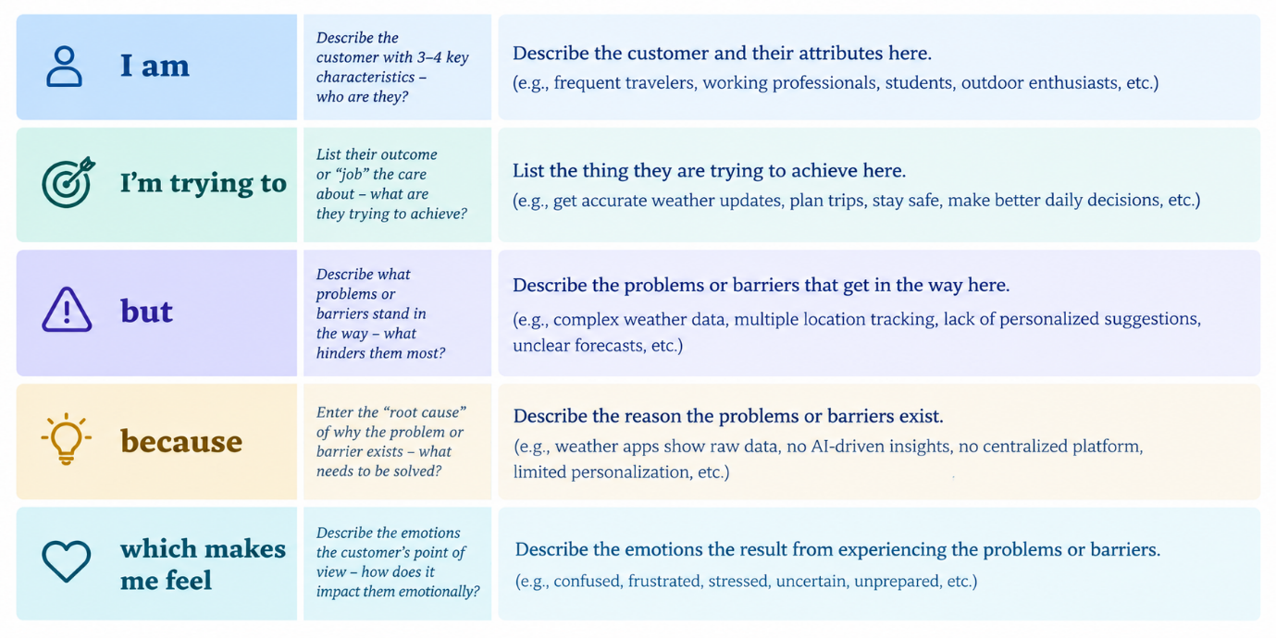

Example:
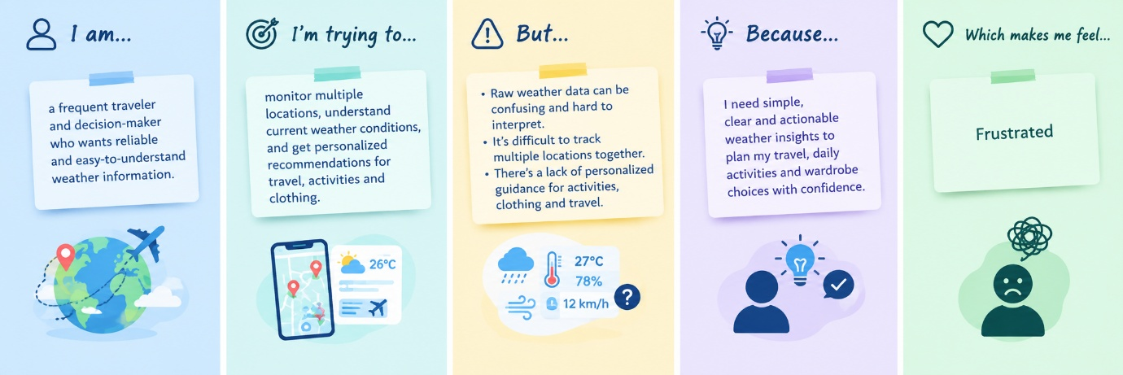
Problem Statement (PS) | I am (Customer) | I’m trying to | But | Because | Which makes me feel
PS-1 | Frequent traveler | Monitor weather and plan travel/activities | Raw weather data is difficult to understand | It lacks simple personalized guidance | Confused and unprepared
PS-2 | Weather-aware user | Get travel, activity, and clothing recommendations | General weather information is not personalized | Weather data is mostly presented as raw information | Unsure about what to do and wear

